**NAME: SHEIKH ABDUL WAHAB ALI**

**CLASS: BSCS -1B (EVENING)**

**ARID NO: 21-ARID-669**

**ASSIGNMENT: 07**

**SUBMITTED TO: SIR MUZAFFAR IQBAL**

**Q1(a): Write a function to accepts a string (an array of characters) and reverses it. Use a for loop that swaps the first and last characters, then the second and next-to-last characters, and so on. If the given string is “islamabad” then the output will be “dabamalsi”. Write main function to implement the above function. C++?**

**Program:**

#include <iostream>

#include "cstring"

using namespace std;

void rev(string);

int main()

{

    string s;

    cout<<"Enter The String:";

    getline(cin,s);

    cout<<"Reverse String:";

    rev(s);

    return 0;

}

void rev(string n)

{

    int i;

    for(i=n.size();i>=0;i--)

     {

        cout<<n[i];

     }

}

**OUTPUT:**

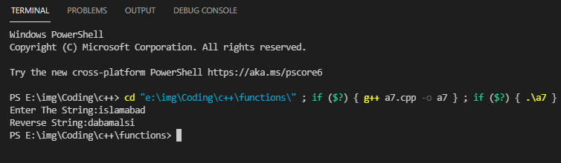

**Q1(b): Write a function to accepts a string (an array of characters) and reverses it. Use a for loop that swaps the first and last characters, then the second and next-to-last characters, and so on. If the given string is “islamabad” then the output will be “dabamalsi”. Write main function to implement the above function. C?**

**Program:**

#include <iostream>

#include "cstring"

using namespace std;

void rev(char[]);

int main()

{

    char s[50];

    cout<<"Enter The String:";

    cin.getline(s,50);

    cout<<"Reverse String:";

    rev(s);

    return 0;

}

void rev(char n[])

{

    int i,s=strlen(n);

    for(i=s;i>=0;i--)

     {

        cout<<n[i];

     }

}

**OUTPUT:**



**Q2: Write a function that will allow a floating-point number to be raised to an integer power. In other words, evaluate the formula y=xn where y and x are floating-point variables and n is an integer variable.Write main function to implement the above function. ?**

**Program:**

#include <iostream>

#include <cmath>

using namespace std;

double powerf(double,int);

int main()

{

    int n;

    double y,x;

    cout<<"Enter a Number:";

    cin>>x;

    cout<<"Enter a Power of Number:";

    cin>>n;

    y=powerf(x,n);

    cout<<"Power of Number:"<<y;

    return 0;

}

double powerf(double b,int c)

{

    return pow(b,c);

}

**Output:**

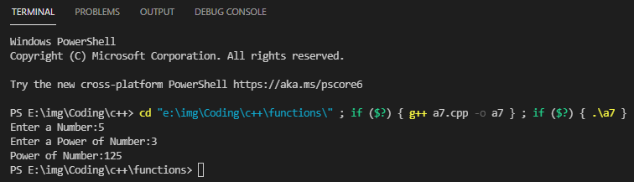

**Q3: Write a function that takes an integer value and returns the number with its digits reversed. For example, given the number 7631, the method should return 1367. ?**

**Program:**

#include <iostream>

using namespace std;

int rev(int);

int main()

{

    int n,rn;

    cout<<"Enter a Number:";

    cin>>n;

    rn=rev(n);

    cout<<"Reverse of Number:"<<rn;

    return 0;

}

int rev(int x)

{

    int rev=0,remainder;

    while (x != 0) {

        remainder = x % 10;

        rev = rev * 10 + remainder;

        x /= 10;

    }

    return rev;

}

**OUTPUT:**

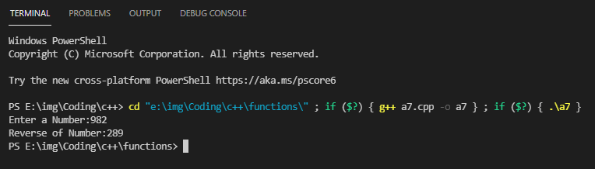

**Q4: An integer number is said to be a perfect number if its factors, including 1 (but not the number itself), sum to the number. For example, 6 is a perfect number, because 6 = 1 + 2 + 3. Write a function is Perfect that determines if parameter number is a perfect number. Use this function in a program that displays all the perfect numbers between 100 and 200. ?**

**Program:**

#include <iostream>

using namespace std;

void perfectnumber()

 {

     int n=100,r=200,i,sum=0;

     while(n<=r)

     {

         sum=0;

         for(i=1;i<n;i++)

          {

              if(n%i==0)

               {

                   sum=sum+i;

               }

          }

          if(sum==n)

          {

              cout<<n<<" is a Perfect Number"<<endl;

          }

          else

          {

              cout<<n<<" is not a Perfect Number"<<endl;

          }

          n++;

     }

 }

int main()

{

    perfectnumber();

    return 0;

}

**OUTPUT:**

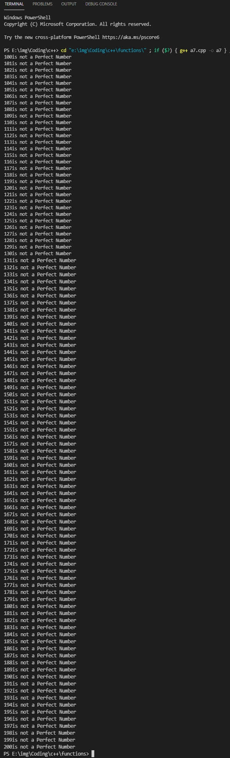

**Q5: Write a function to accept temperature in fahrenheit and return its equivalent celsius by using the following calculation celsius = 5.0 / 9.0 * ( fahrenheit - 32 ).Write main function to implement the above function.?**

**Program:**

#include <iostream>

using namespace std;

float fahrentocel(float);

int main()

{

    float fahren,celcious;

    cout<<"Enter Temperature in Fahrehit:";

    cin>>fahren;

    celcious=fahrentocel(fahren);

    cout<<"Temperature in Celcious:"<<celcious<<char(248)<<"C";

    return 0;

}

float fahrentocel(float fahrenhit)

{

    float celsius;

    celsius=(fahrenhit-32)*5/9;

    return celsius;

}

**Output:**

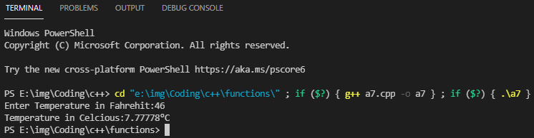

**Q6: Write a function to accept an integer array and sort it in ascending order. Write main function to implement the above function.?**

**Program:**

#include <iostream>

using namespace std;

int size;

void bubblesort(int[]);

int main()

{

    cout<<"Enter the Size of an Array:";

    cin>>size;

    int array[size],resultant_array[size],i;

    cout<<"Enter The Elements of an Array:\n";

    for(i=0;i<size;i++)

    {

        cin>>array[i];

    }

    bubblesort(array);

    return 0;

}

void bubblesort(int arr[])

{

    int i,j,t;

    for(i=0;i<size;i++)

    {

        for(j=0;j<(size-1);j++)

        {

            if(arr[j]>arr[j+1])

            {

            t=arr[j];

            arr[j]=arr[j+1];

            arr[j+1]=t;

            }

        }

    }

    cout<<"The Sorted Array in Ascending Order is:\n";

    for(i=0;i<size;i++)

     {

         cout<<arr[i]<<endl;

     }

}

**Output:**

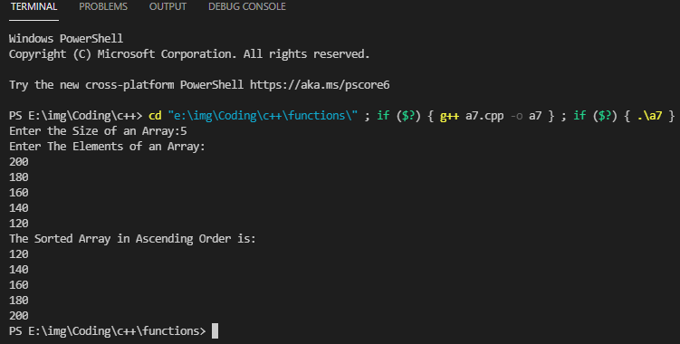

**Q7: Write a function to accept an integer array and return the largest element of the array. Write main function to implement the above function.?**

**Program:**

#include <iostream>

#include <climits>

using namespace std;

int size;

void input1darray(int arrayname[])

{

     cout<<"Enter The Array Elements:\n";

     int i;

     for(i=0;i<size;i++)

     {

     cin>>arrayname[i];

     }

}

int largest1darray(int arrayname[])

{

    input1darray(arrayname);

     int i,max=INT_MIN;

     for(i=0;i<size;i++)

     {

         if(arrayname[i]>max)

         {

              max=arrayname[i];

         }

     }

     return max;

}

int main()

{

    int largest,arr[size];

    cout<<"Enter The Size of Array:";

    cin>>size;

    largest=largest1darray(arr);

    cout<<"Largest:"<<largest;

    return 0;

}

**Output:**

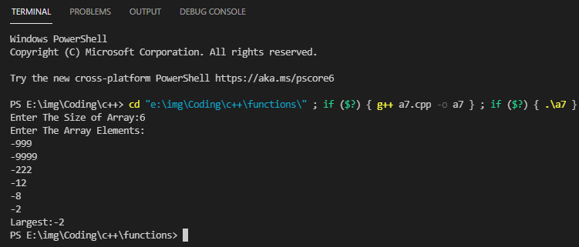

**Q8: Write a function to accept an integer and display its table. For example if the function accepts 5 then it should display its table as below…**

**1 * 5 = 5**

**2 * 5 = 10**

**3 * 5 = 15**

**…**

**…**

**10 * 5 = 50**

**Write main function to implement the above function.?**

**Program:**

#include <iostream>

using namespace std;

int size;

void table(int size,int n)

{

    int i;

    for(i=1;i<=size;i++)

     {

         cout<<n<<"X"<<i<<"="<<n*i<<endl;

     }

}

int main()

{

    int number;

    cout<<"Enter The Number:";

    cin>>number;

    cout<<"Enter the size of table:";

    cin>>size;

    table(size,number);

    return 0;

}

**OUTPUT:**

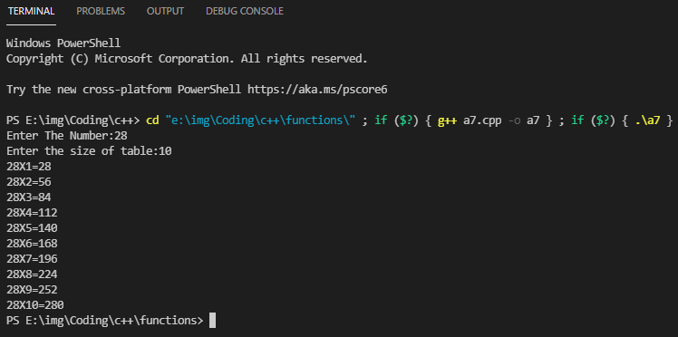

**Q9**: **Write a function to accept an array of strings and return the largest string. Write main function to implement the above function.?**

**Program:**

#include <iostream>

#include <cstring>

using namespace std;

int size;

string largest(char name[])

{

   int i;

   char large[]="abc";

   for(i=0;i<size;i++)

    {

        int result=strcmp(name,large);

        if(result>0)

        {

            strcpy(large,name);

        }

    }

    return large;

}

int main()

{

    cout<<"Enter The Size of String:";

    cin>>size;

    cin.ignore();

    char str[50];

    string l;

    int i;

    for(i=0;i<size;i++)

     {

         cout<<"Enter The String "<<i+1<<":";

         cin.getline(str,50);

     }

     l=largest(str);

     cout<<"The Largest String with ASCII is:"<<l;

   return 0;

}

**OUTPUT:**

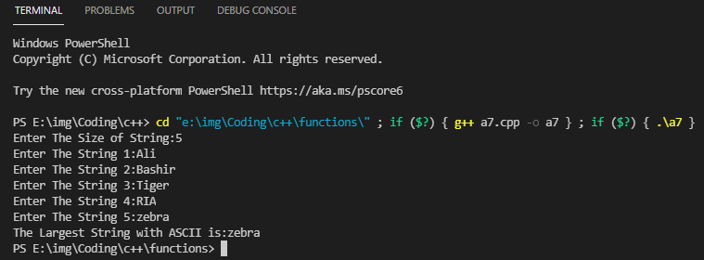

**Q10: Write a function to accept a string and convert it into lower case. The function should return this new string converted into lower case. Write main function to implement the above function.?**

**Program:**

#include <iostream>

using namespace std;

char uppercasetolowercase(char upper)

{

    int ascii;

    char lower;

    ascii=upper;

    ascii=ascii+32;

    lower=ascii;

    return lower;

}

int main()

{

    char cupper,clower;

    cout<<"Enter a Character in UpperCase:";

    cin>>cupper;

    clower=uppercasetolowercase(cupper);

    cout<<"Lower Case of Your Typed Character is:"<<clower;

    return 0;

}

**OUTPUT:**

